AI Powdered Email Assistant
High Level Architecture
This is an AI Email Composer built with Streamlit and LangGraph. It uses multiple specialized agents to generate an email with tone and length controls, then reviews grammar and tone before showing the final draft.the system maintains short-term memory for the same tone . I also implemented guardrails that validate the generated content against restricted rules. If a draft fails validation or quality checks ,it gives you error saying “Sorry — I can’t generate this email because it may contain sensitive or restricted content. "
"Please remove sensitive details and try again."” The final draft is editable subject and Body and can be exported to an email client or downloaded as a PDF

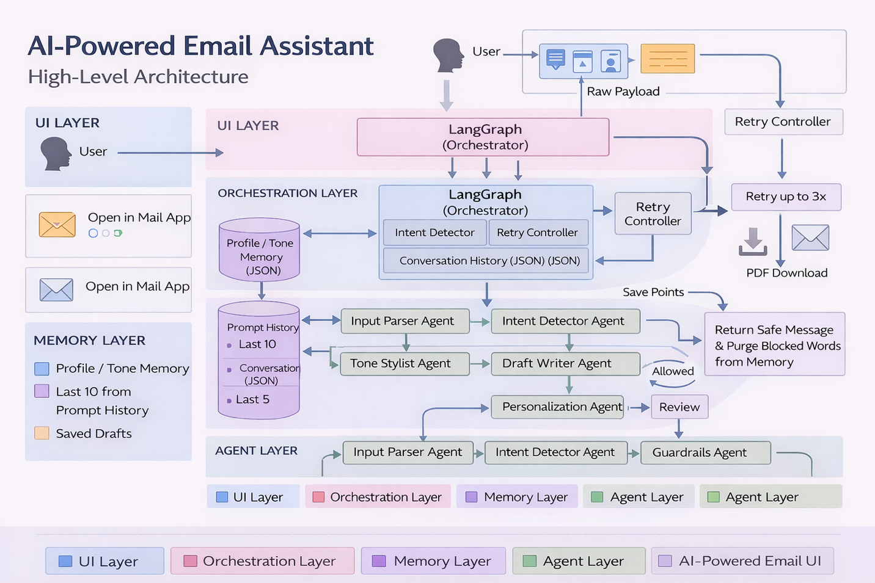
Guardrails
BLOCKLIST_WORDS = [
"password",
"ssn",
"social security",
"credit card",
"bank account",
"wire transfer",
"phising”,
“hack”
]
WORKFLOW DIAGRAM
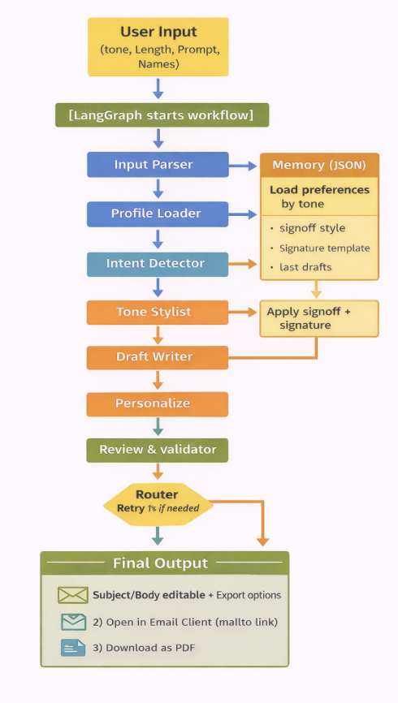

🔹 How the System Works
User → Streamlit UI
- User enters email request and tone preference
LangGraph (Orchestrator)
- Acts as the central controller
- Coordinates multiple AI agents
- Manages workflow and data flow
AI Agent Pipeline
- Input Parser Agent – structures user input
- Intent Detector Agent – understands email purpose
- Tone Stylist Agent – applies selected tone
- Draft Writer Agent – generates email content
- Personalization Agent – customizes with names & context
Memory Layer (JSON)
- Stores tone and profile preferences
- Ensures consistent personalization
Final Output
- Personalized email draft
- 📄 Download as PDF
- 📧 Open in email client

